**Group report of project**

Ziyue Wu

Zhiying Chen

Xin Wei sc19xw

First of all, after careful analysis and understanding of the project, we divided the project into three parts, which are: 1. Drive the robot to walk to the specified position according to the specified coordinates. 2. After the robot has reached the recognition positions of the entrances of the two rooms, it recognizes the red and green rooms respectively, and recognizes the green rooms. 3. After the robot arrives at the center point of the green room, it recognizes the picture hanging on the wall and saves the recognition picture and the print image name. Then Xin Wei is responsible for the first part, Zhiying Chen is responsible for the second part, and Ziyue Wu is responsible for the third part.

In the first part, Xin Wei use the coordinates provided in the “input_points.yaml” file to let the robot walk to the entrance of the room1. After reaching the specified position, the terminal will report "the robot has reached the specified position", and then the robot will start to rotate. With the help of the teammate's recognition instruction, If the first room the robot recognizes is a red room, the robot will walk to the entrance of room2 according to the movement instructions, then start to rotate and recognize, and then recognize the green room and continue to move to the central location of green room according to the specified coordinates.

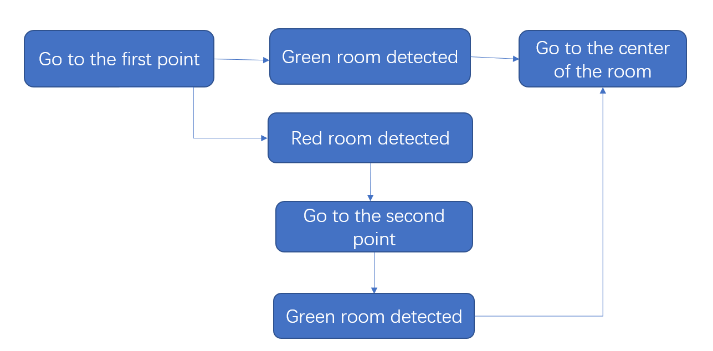

In the second part, Zhiying Chen solves the problem mainly through the design of circle recognition. Firstly, the circle_detection method defines two flags in the programme, red_flag and green_flag, to indicate if the robot has captured valid red object or green object, we will use the flags later in the code. The programme then defines the boundaries of the green filter and the red filter, calibrated with green and red circle pictures in the simulated room. The image captured by the robot is then filtered and converted to grey scale images respectively for green color and red color. The areas of valid colors that appear in the image are calculated as red_max_area and green_max_area. The coordinate of the centre of green color is calculated as cx and cy. If the either the value of red_max_area or green_max_area exceeds the threshold (currently 1000, to be adjusted later in testing), and the x coordinate of the center of the green color is between 280 and 360 (approximately the center area of the captured image), then the respective flag will be updated to 1, and returned as the output of the function. Otherwise the flags will remain as default 0.

In the third part, Ziyue Wu mainly design and complete the task of character recognition. The following figure shows the logic executed by the robot in the green room. The design details of the circles 1(Matching strategy) and 2(Path strategy) will be explained in detail later. Firstly, the robot enters the room and reaches the center point of the room. Then, start the template matching strategy and rotate it in place for one round. If the character is found and the matching is successful, the picture and character name will be saved, and if not found, the path strategy will be turned on.

